**Introduction**

The project focuses on analysing a dataset related to books, aiming to gain insights into various aspects such as ratings, publication years, genres, and more.

Through exploratory data analysis and visualization techniques, we seek to uncover patterns, trends, and relationships within the dataset.

By leveraging tools like histograms, kernel density plots, scatter plots, and pair plots, we aim to provide a comprehensive understanding of the dataset and extract valuable insights that can inform decisions in the publishing industry, marketing strategies, or even recommendations for readers.

The provided code conducts exploratory data analysis (EDA) on a dataset related to books using Python libraries such as Pandas, Matplotlib, and Seaborn. The dataset seems to contain various attributes related to books, such as average rating, number of pages, publication year, categories, and ratings count. Through visualizations and summary statistics, the code aims to uncover insights into the distribution, relationships, and patterns within the dataset, facilitating better understanding and interpretation of the data

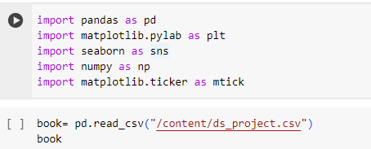

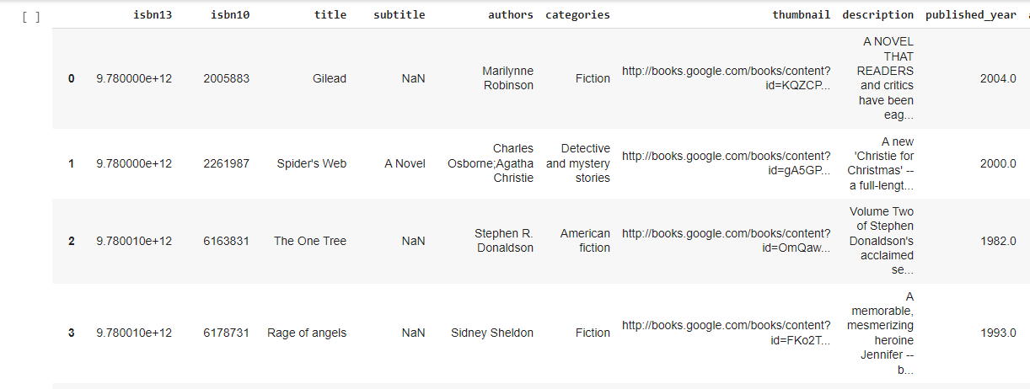

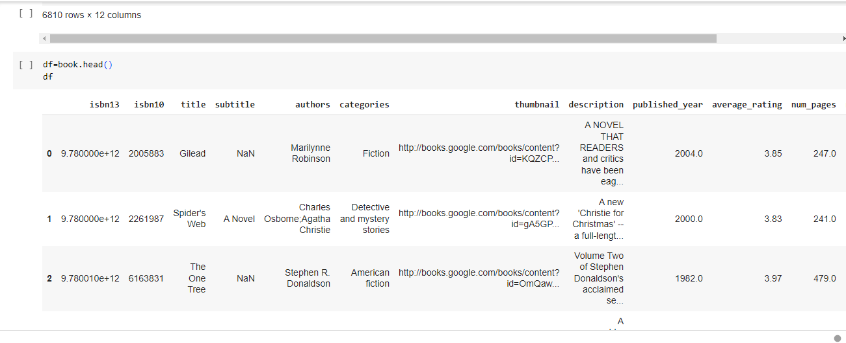

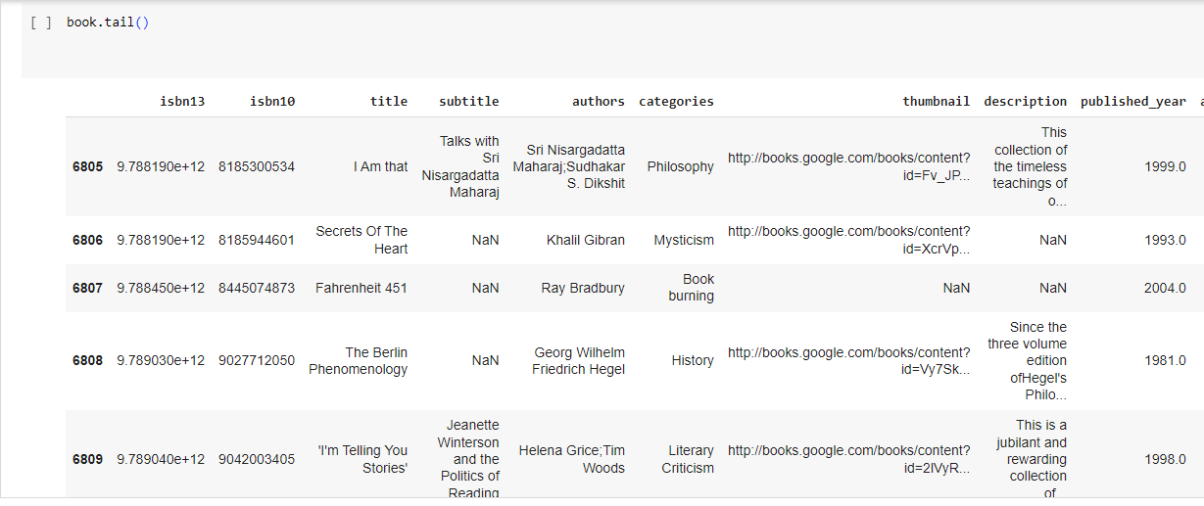

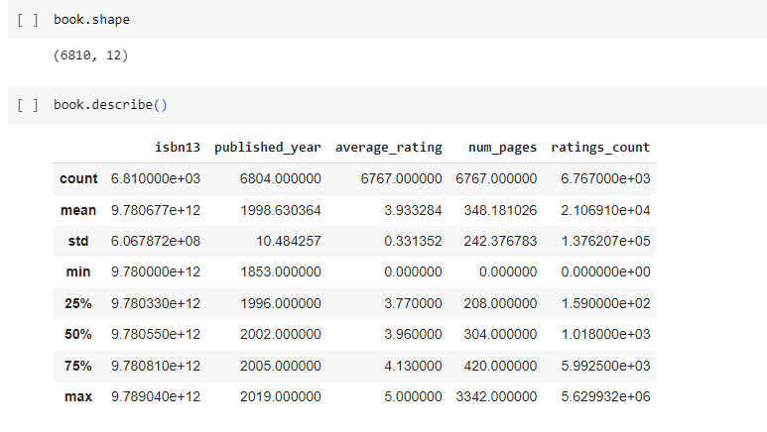

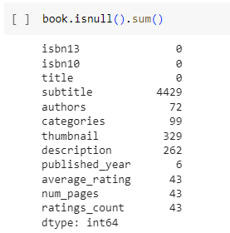

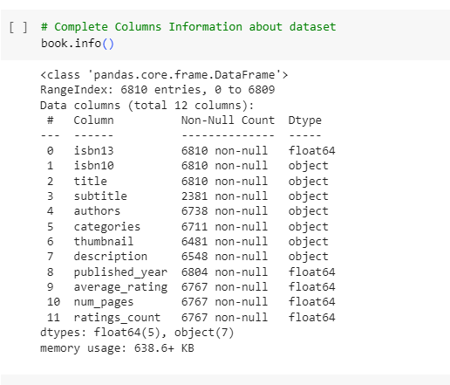

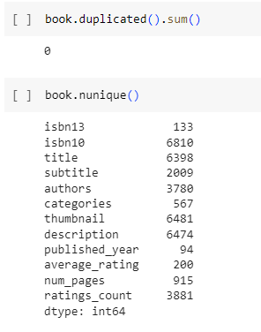

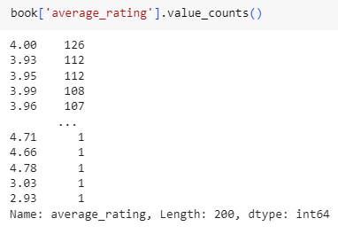

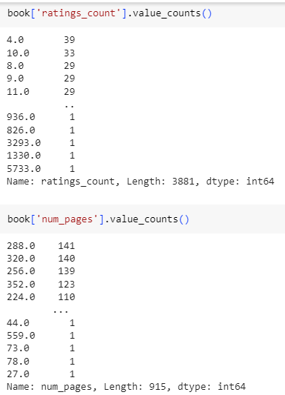

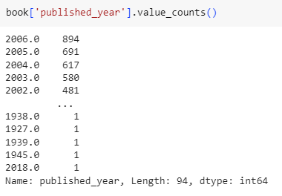

**UNIVARIATE:**

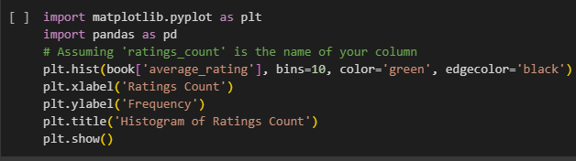

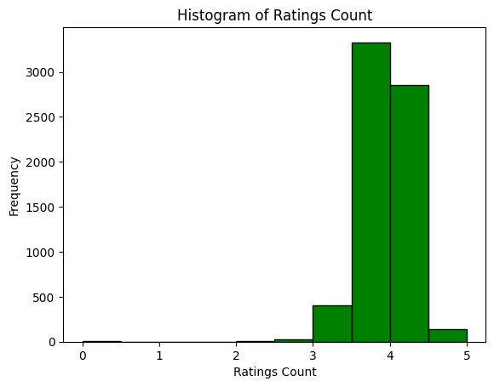

**CONCLUSION:**

**THIS VISUALLIZATION HELPS TO UNDERSTAND THE DISTRUBUTION AND THE FREQUNCY OF RATINGS COUNTS FOR THE BOOK IN THE DATA SET ,PROVIDING VALUABLE INSIGHTS INTO THE POPULARITY AND ENGAGEMENT LEVELS OF THE BOOK**

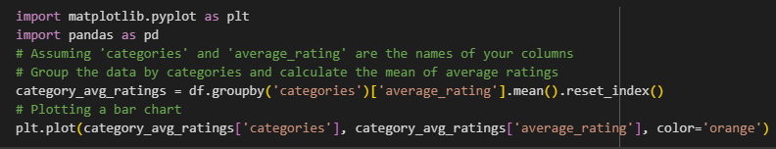

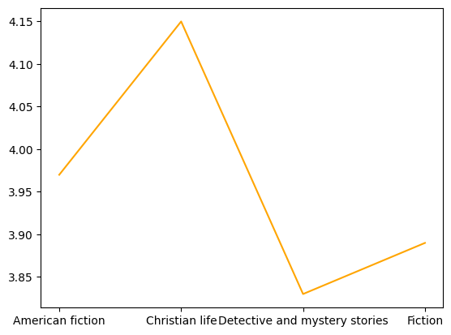

CCONCLUSION: THIS this visualization provides insights into the average rating of books across different categories adding to understanding reader preferences and potentially pin forming decision related to publishing marketing or recommending books with specific changes all topics

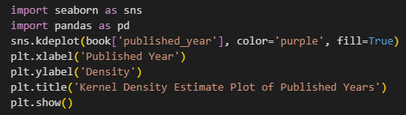

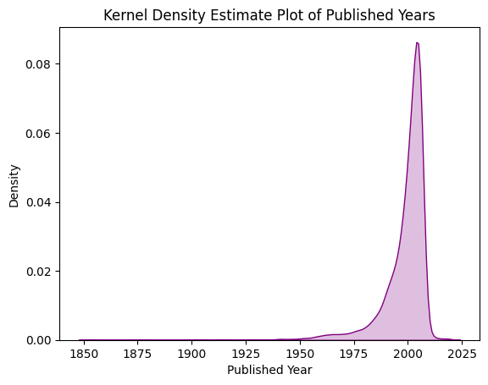



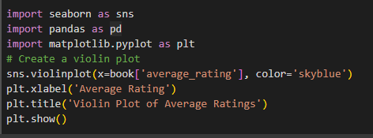

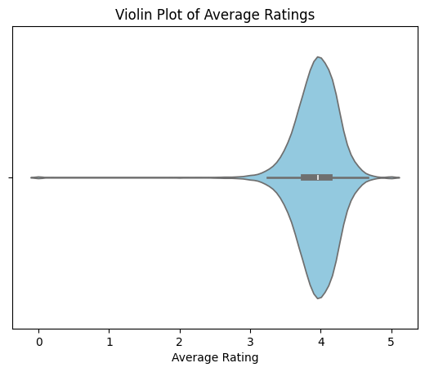



**BBIVARIENT:**

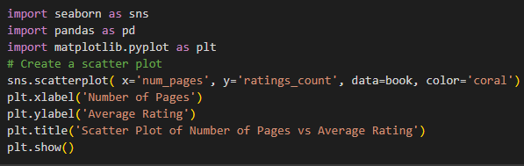

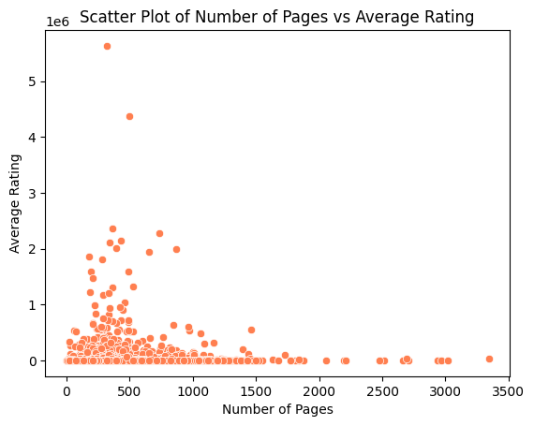



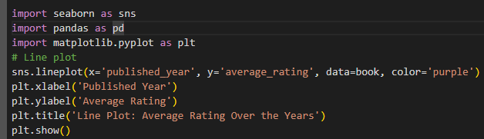

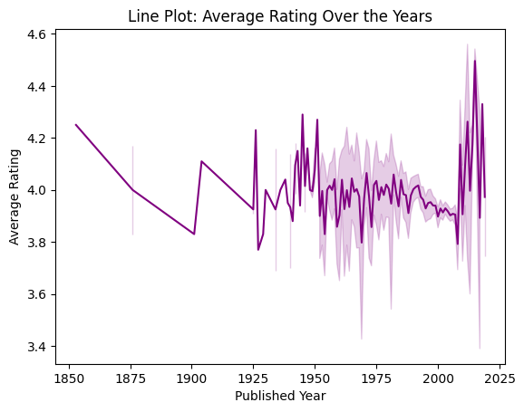



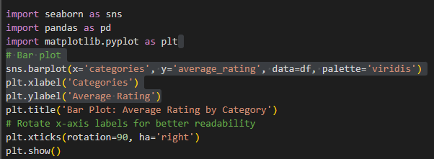

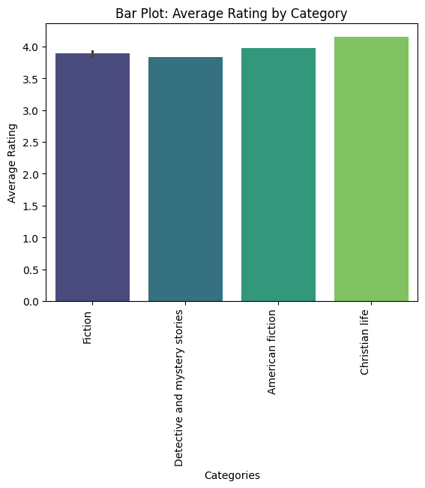



**MULTIVARIENT:**

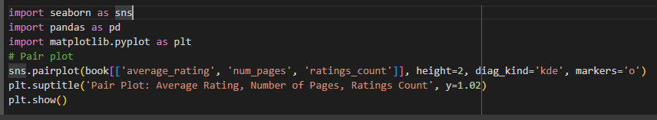

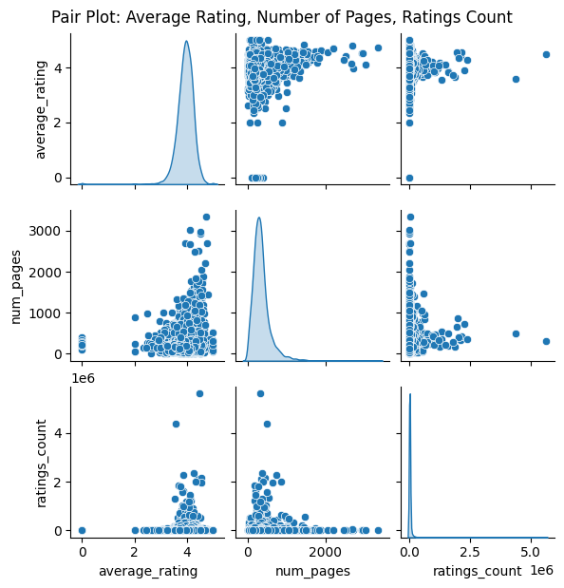



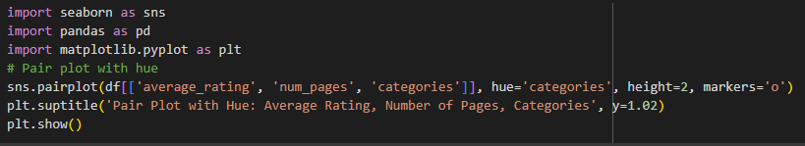

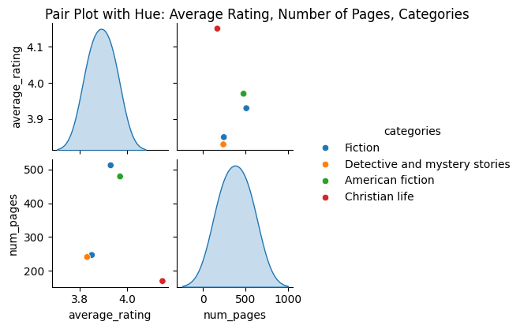



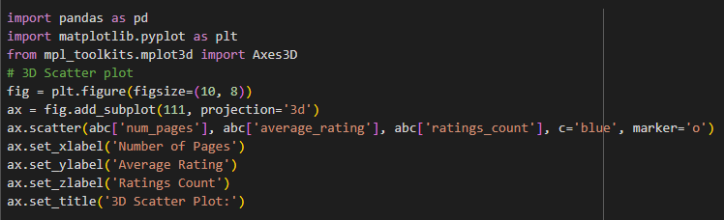

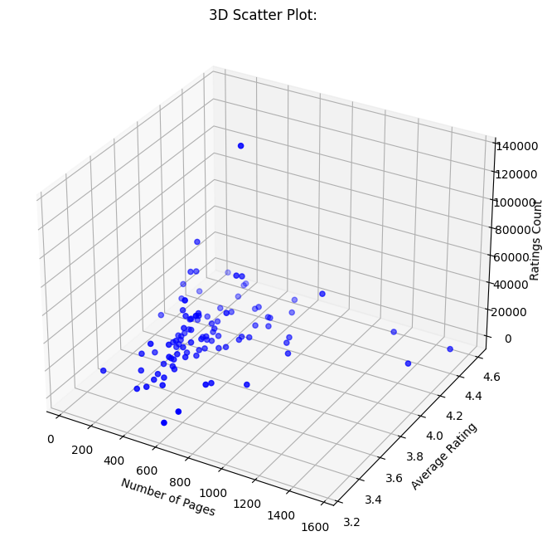



**this visualization provides insights into the average ratings of books across different categories, aiding in understanding reader preferences and potentially informing decisions related to publishing, marketing, or recommending books within specific genres or topics.**

**Conclusion**

In this project, we have conducted a thorough analysis of a dataset containing information about books. Through various visualizations and statistical summaries, we have gained insights into the distribution of ratings, trends in publication years, relationships between variables like number of pages and ratings count, and comparisons across different book categories.

These insights can be invaluable for publishers, authors, marketers, and readers alike. By understanding the dynamics of book ratings, publication trends, and reader preferences, stakeholders can make informed decisions regarding book publishing, marketing campaigns, and content recommendations.

ultimately enhancing the overall experience for both creators and consumers in the world of literature.

In conclusion, the exploratory data analysis conducted on the book dataset has provided valuable insights into various aspects of the data:

1. Data Summary and Quality Check: Initial exploration included examining the structure, summary statistics, missing values, duplicates, and unique values within the dataset. This step ensures data integrity and provides a basic understanding of the dataset's characteristics.

2. Univariate Analysis: Visualizations such as histograms, kernel density estimation plots, violin plots, and line plots were utilized to understand the distribution and frequency of individual variables like average rating, number of pages, publication year, and ratings count. These visualizations offer insights into the distributional characteristics and variability within the dataset.

3. Bivariate Analysis: Scatter plots, line plots, and bar plots were employed to explore relationships between pairs of variables and across different categories. These visualizations help identify potential correlations, trends, and differences between variables, aiding in deeper understanding and interpretation of the data.

4. Multivariate Analysis: Pair plots and 3D scatter plots were used to explore relationships among multiple variables simultaneously, providing comprehensive insights into the complex interactions and patterns within the dataset. These visualizations facilitate exploratory data analysis and offer a deeper understanding of the data structure.

Overall, the exploratory data analysis conducted on the book dataset has provided meaningful insights into various aspects of the data, enabling better understanding, interpretation, and decision-making processes. These insights can inform various stakeholders in the book industry, such as publishers, marketers, and researchers, for making informed decisions and strategies.